ASSIGNMENT-6.5
HT.NO:2303A510F9
Batch.No:30
Task 1: Use an AI tool to generate eligibility logic.
Prompt:
Generate a Python script that validates voter eligibility based on minimum age and citizenship status.
Code and Output:
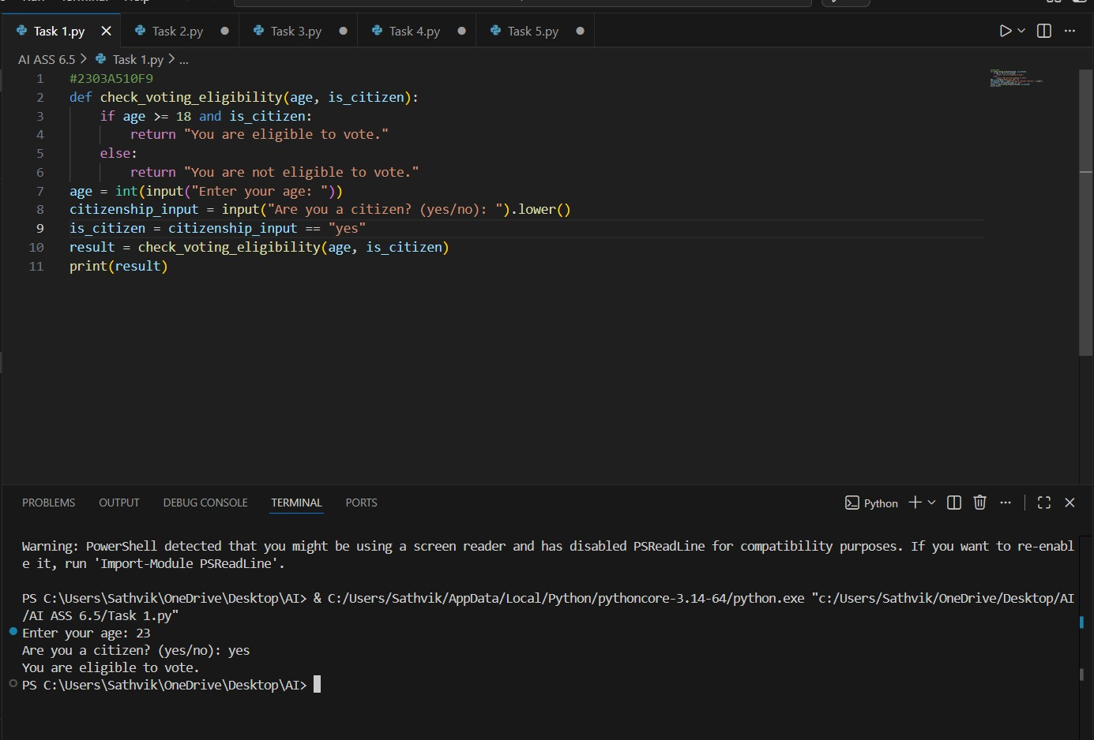

Observation:
The conditional logic correctly determines voting eligibility based on age and citizenship.

Task 2: Use an AI tool to process strings using loops.
Prompt:
Generate a Python program that iterates through a given string and displays the total number of vowels and consonants.
Code and Output:
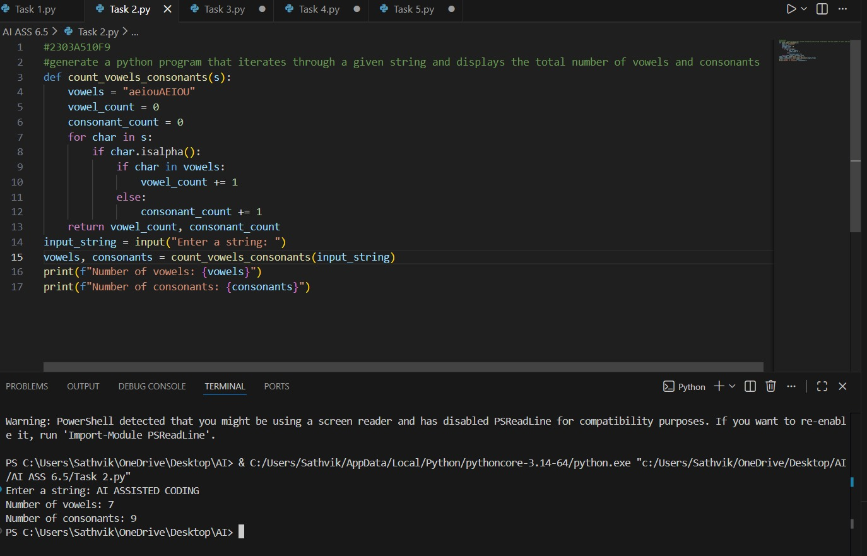

Observation:
The program accurately processes the string and provides correct vowel and consonant counts.
Task 3: Use an AI tool to generate a complete program using classes, loops, and conditionals.
Prompt:
Create a complete Python program for a library management system using classes, loops, and conditional statements.
Code:
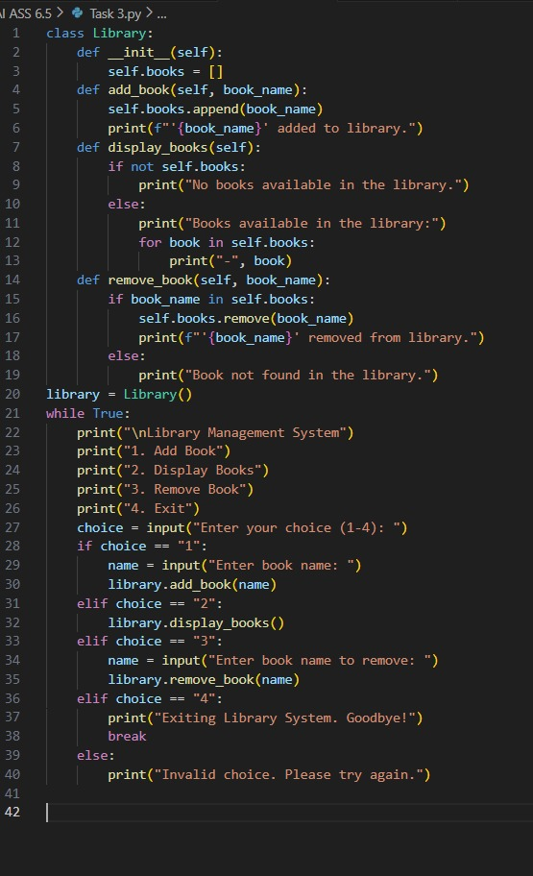

Output:
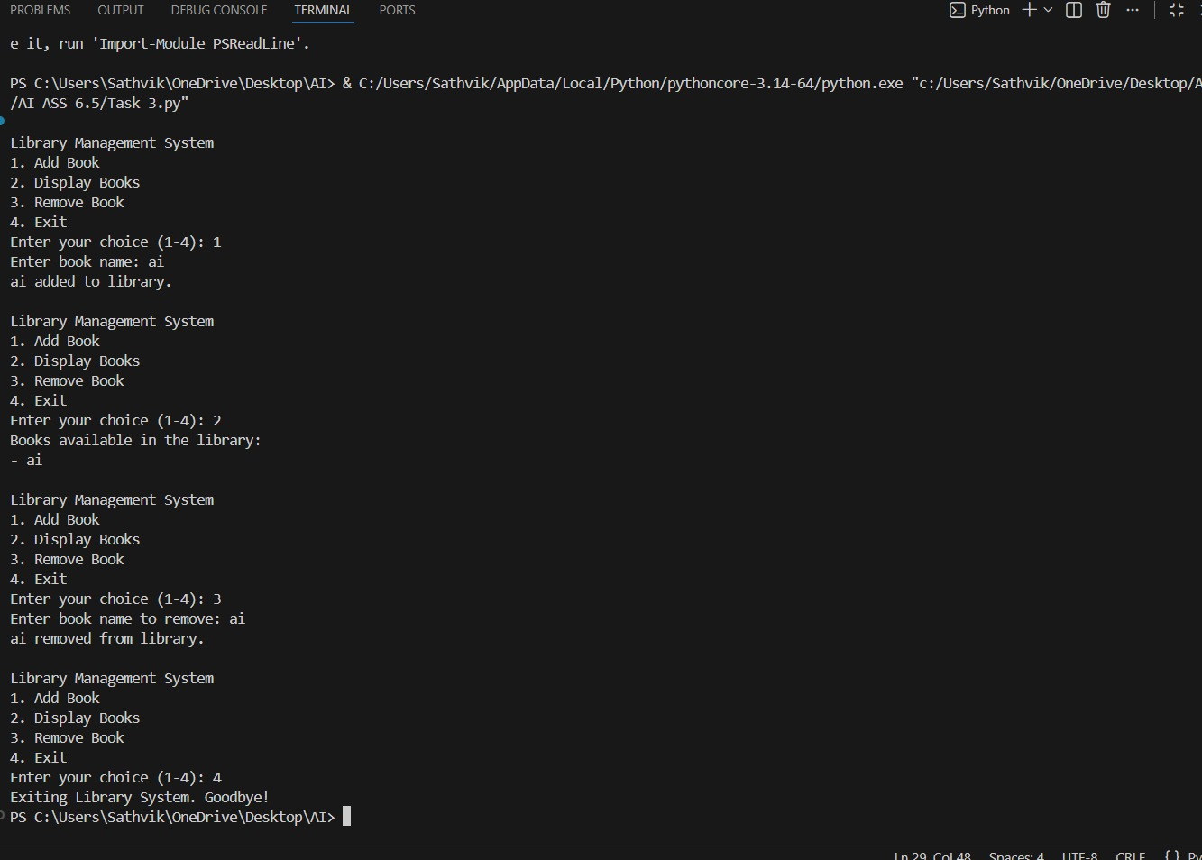

Observation:
The program uses a class to organize library operations such as adding, displaying, and removing books. A menu-driven loop with conditional statements allows continuous interaction with the user. Overall, the code clearly demonstrates the practical use of classes, loops, and conditionals.

Task 4: Use an AI tool to generate an attendance management class.
Prompt:
Generate a Python class that records and displays student attendance using loops.
Code:
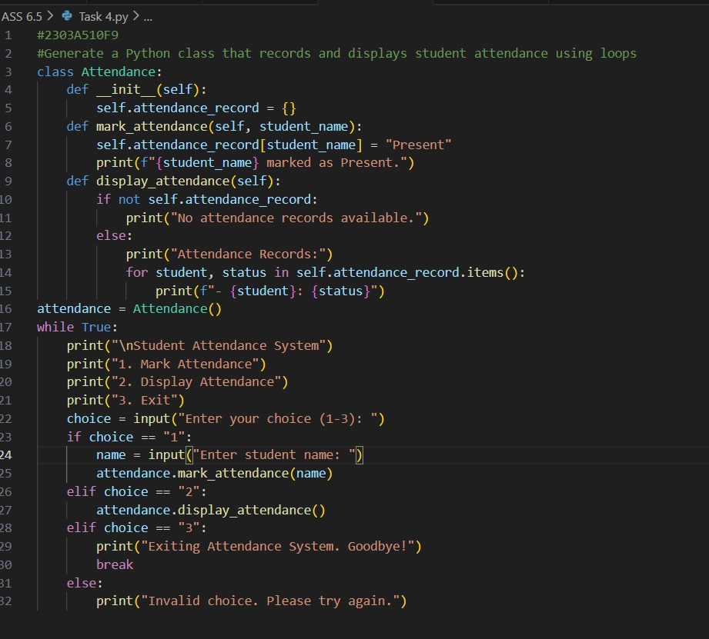

Output:
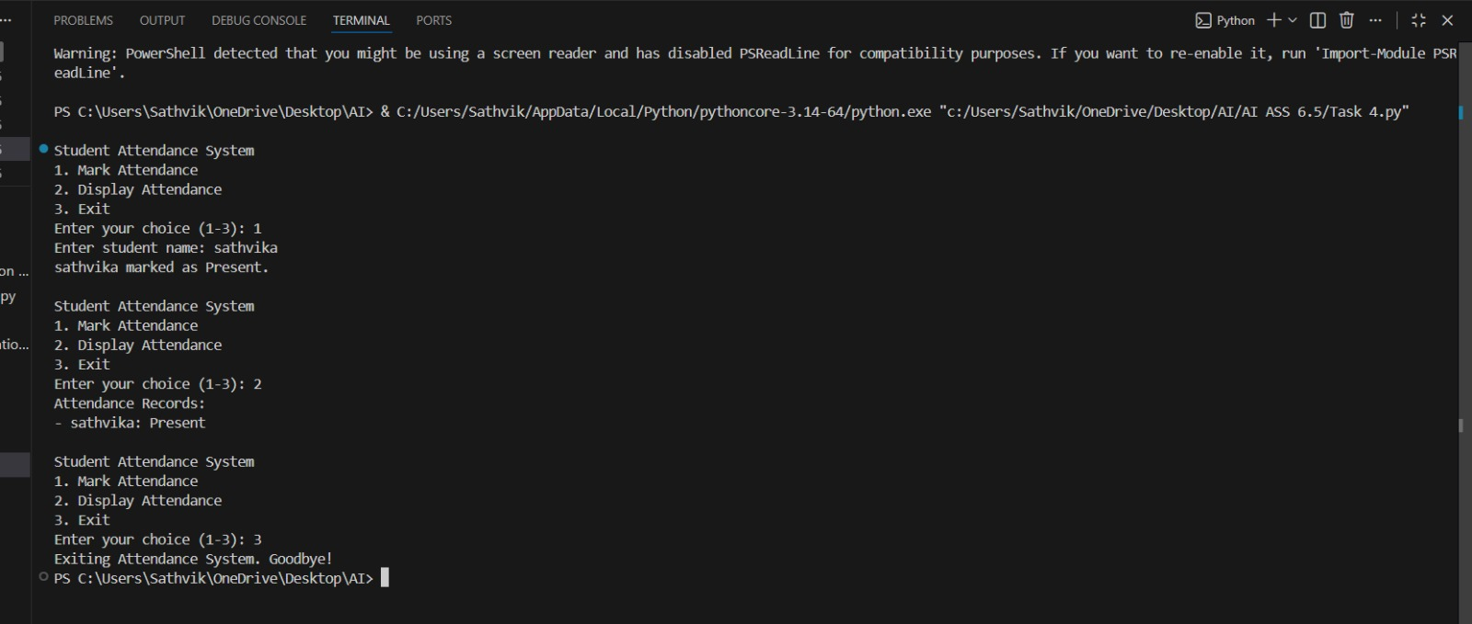

Observation:
The program uses a class to store and manage student attendance records efficiently. A menu-driven loop with conditional statements allows marking and displaying attendance. The attendance details are displayed correctly using dictionary traversal.

Task 5: Use an AI tool to complete a navigation menu.
Prompt:
Develop a Python program that simulates an ATM system using loops and conditional statements.
Code:
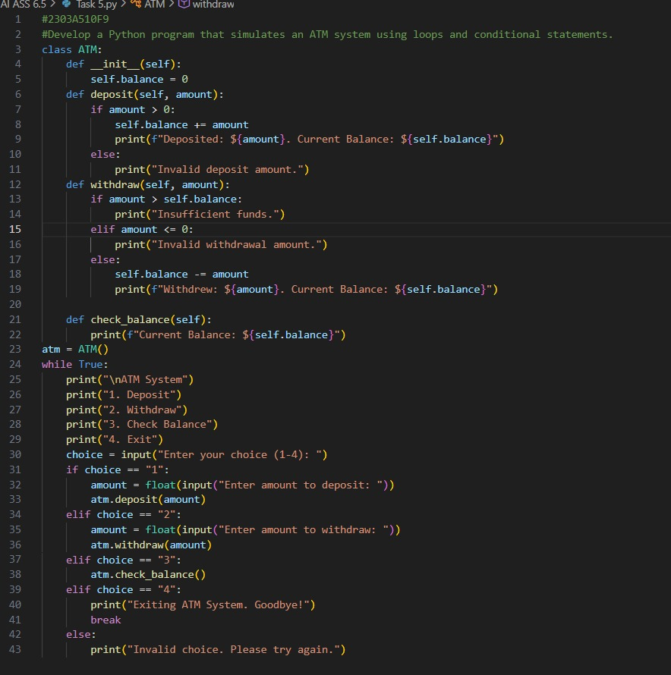

Output:
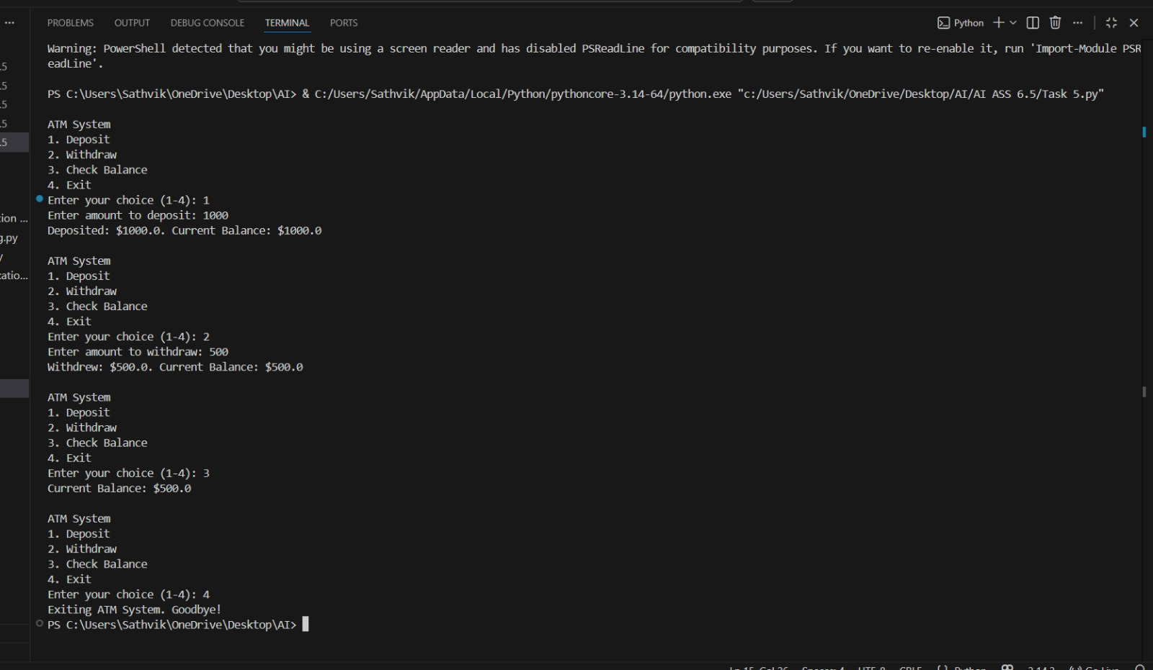
Observation:
The program uses a class to manage ATM operations such as deposit, withdrawal, and balance enquiry. A menu-driven loop with conditional statements allows continuous user interaction. Input validation is handled properly to prevent invalid transactions and insufficient balance errors.

